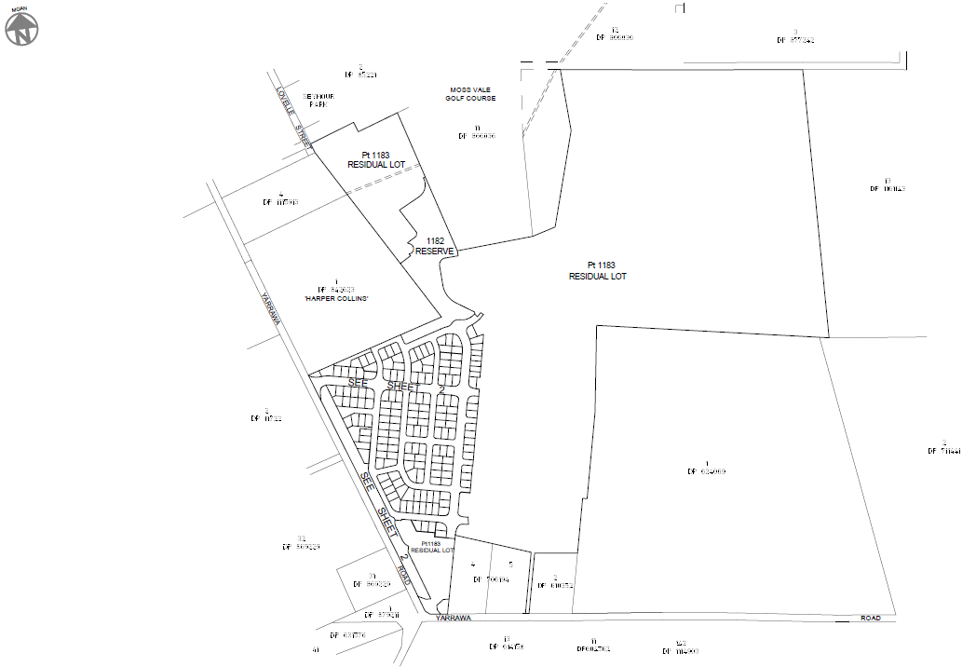
Proposed Stage 1 subdivision in south east corner of the site

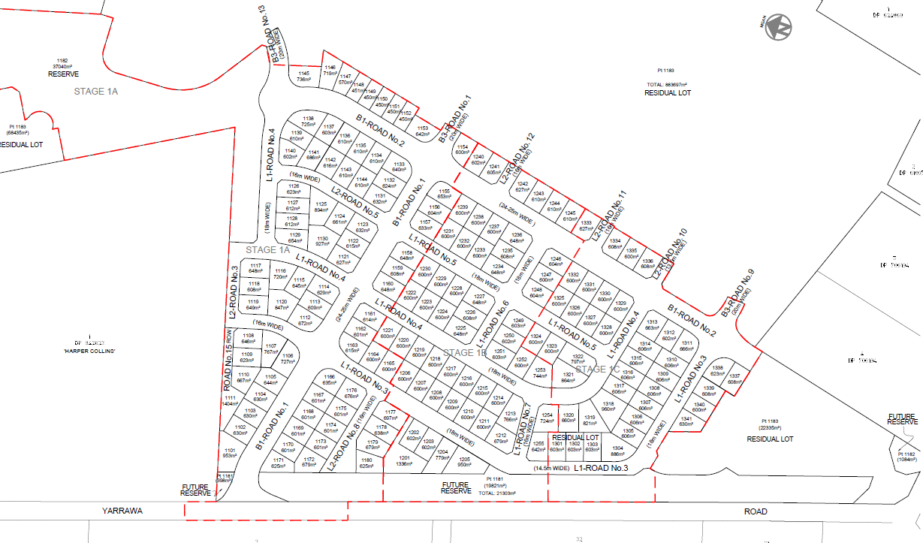
Proposed Stage 1 subdivision in south east corner of the site

